Project Planning Phase
Project Planning Template (Product Backlog, Sprint Planning, Stories, Story points)

Date | 05 October 2026
Team ID | SWTID-2026-9175
Project Name | Auto Ticket Classification using Flow Designer
Maximum Marks | 5 Marks

Product Backlog, Sprint Schedule, and Estimation (4 Marks)
Use the below template to create product backlog and sprint schedule
Sprint | Functional Requirement (Epic) | User Story Number | User Story / Task | Story Points | Priority | Team Members
Sprint-1 | Ticket Creation | USN-1 | As a student / teacher, I can create an IT support ticket by entering my name (Caller) and a short description of the issue. | 2 | High | Rohini R
Sprint-1 | Ticket Creation | USN-2 | As a student / teacher, I do not need to select Category or Subcategory manually. | 3 | High | Rohini R
Sprint-1 | Auto Classification | USN-4 | As an IT agent, I want Wi-Fi / Network tickets classified as Network > Wi-Fi automatically. | 3 | High | Rohini R
Sprint-1 | Auto Classification | USN-5 | As an IT agent, I want Projector, Password and Slow Computer tickets classified automatically. | 3 | High | Rohini R
Sprint-1 | Configuration | USN-7 | As an administrator, I can set up Category and Subcategory choices with dependency. | 3 | Medium | Rohini R
Sprint-2 | Email Notification | USN-3 | As a student / teacher, I receive an email confirming that my request has been submitted. | 2 | High | Rohini R
Sprint-2 | Ticket Management | USN-6 | As an IT agent, I can view classified tickets and update State, Assigned group and Assigned to. | 2 | Medium | Rohini R
Sprint-2 | Flow Maintenance | USN-8 | As an administrator, I can edit the flow to add new keywords in future. | 3 | Medium | Rohini R
Sprint-2 | Deployment | USN-9 | As an administrator, I can export the project as an update set XML to share it. | 1 | Low | Rohini R

Project Tracker, Velocity & Burndown Chart: (4 Marks)
Sprint | Total Story Points | Duration | Sprint Start Date | Sprint End Date (Planned) | Story Points Completed (as on Planned End Date) | Sprint Release Date (Actual)
Sprint-1 | 14 | 3 Days | 02 Feb 2026 | 04 Feb 2026 | 14 | 04 Feb 2026
Sprint-2 | 8 | 3 Days | 05 Feb 2026 | 07 Feb 2026 | 8 | 07 Feb 2026

Velocity:
Imagine we have a 10-day sprint duration, and the velocity of the team is 20 (points per sprint). Let’s calculate the team’s average velocity (AV) per iteration unit (story points per day)

Velocity for Auto Ticket Classification using Flow Designer:
Total story points = 14 + 8 = 22; number of sprints = 2.
Velocity = 22 / 2 = 11 story points per sprint.
Average velocity per day (3-day sprint) = 11 / 3 = 3.67 story points per day.

Burndown Chart:
A burn down chart is a graphical representation of work left to do versus time. It is often used in agile software development methodologies such as Scrum. However, burn down charts can be applied to any project containing measurable progress over time.
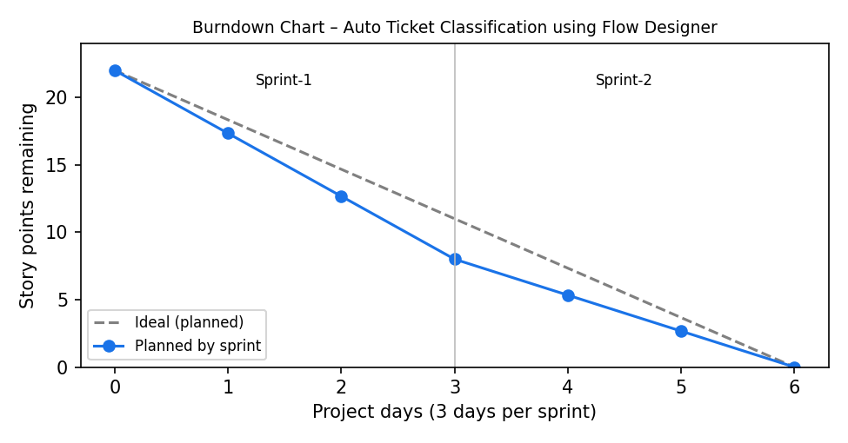

https://www.visual-paradigm.com/scrum/scrum-burndown-chart/
https://www.atlassian.com/agile/tutorials/burndown-charts

Reference:
https://www.atlassian.com/agile/project-management
https://www.atlassian.com/agile/tutorials/how-to-do-scrum-with-jira-software
https://www.atlassian.com/agile/tutorials/epics
https://www.atlassian.com/agile/tutorials/sprints
https://www.atlassian.com/agile/project-management/estimation
https://www.atlassian.com/agile/tutorials/burndown-charts

